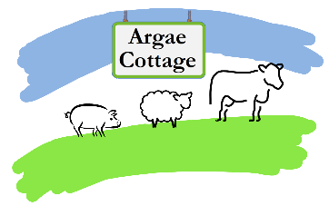**2**

**Christmas Turkey Order Form**

**Name: ________________________________________________**

**Contact phone number: ___________________________________**

**Email: _________________________________________________**

**Turkey Weight required:**

Please refer to website for up to date pricing and availability

|  |  |
| --- | --- |
| **4g** |  |
| **5kg** |  |
| **6kg** |  |
| **7kg** |  |
| **8kg** |  |

**Any comments regarding this order?**

Please send your completed form, along with your deposit of £20 to:

Argae Cottage

Haimwood

Llandrinio

SY22 6SQ

Cheques payable to **C Benson** please.

Or drop off in our post box with cash/cheque payment.

BACS details: Halifax sort code 11-07-01, account number 11343865 (please use your name as payment reference)

**Thank you for your custom!**

**We will contact you to confirm your order when we receive this form.**

**Turkeys will be ready for collection, from our smallholding, on 23rd – 24th December.**