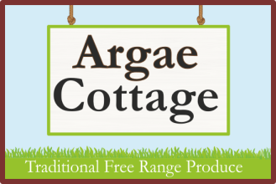**Argae Cottage**

**Haimwood**

**Llandrinio**

**SY22 6SQ**

**01691 830282**

**Chirstmas Produce Order Form**

**Name:_________________________________________________**

**Conatact phone number:___________________________________**

**Email:__________________________________________________**

**Turkey Weight required:**

|  |  |
| --- | --- |
| **4kg (£47.70)** |  |
| **5kg (£58.30)** |  |
| **6kg (£68.90)** |  |
| **7kg (79.50)** |  |
| **8kg (£90.10)** |  |
| **9kg (£100.70)** |  |
| **10kg (£111.30)** |  |

Please send your completed form, along with your deposit of £20 to:

Argae Cottage

Haimwood

Llandrinio

SY22 6SQ

Cheques payable to **C Benson** please.

Or drop off in our post box with cash/cheque payment.

**Thank you for your custom!**

**We will contact you to confirm your order when we receive this form.**

**Turkeys will be ready for collection, from our smallholding, on 22nd – 24th December.**